



PhytoOracle Phenomics Data Processing Pipelines∗

From Field Preparation to Phenotype Information

Emmanuel Miguel Gonzalez, Jeffrey Demieville, Sebastian Calleja, Bryan Pastor, Rodrigo Silva, Duke Pauli

2024-01-30

∗The PhytoOracle project is supported by the following grants: U.S. Department of Energy Biological and Environmental Research (DE-SC0020401) and Advanced Research Projects Agency - Energy OPEN (DE- AR0001101); National Science Foundation Plant Genome Research Program (IOS-2102120, IOS-2023310, and IOS-1849708), Division of Biological Infrastructure (2019674 and 1743442), and CyVerse project (DBI- 1743442); Cotton Incorporated (18-384, 20-720, 21-830, and 23-890); and U.S. Department of Agriculture National Institute of Food and Agriculture Specialty Crop Research Initiative (2021-51181-35903).

**Table of Contents**

1. Field Operations 4
   1. Field Preparation . . . . . . . . . . . . . . . . . . . . . . . . . . . . . . . . . 4
      1. Lettuce Field Preparation . . . . . . . . . . . . . . . . . . . . . . . . 4
      2. Sorghum Field Preparation . . . . . . . . . . . . . . . . . . . . . . . 4
   2. Planting . . . . . . . . . . . . . . . . . . . . . . . . . . . . . . . . . . . . . . 8
      1. Lettuce Planting . . . . . . . . . . . . . . . . . . . . . . . . . . . . . 8
         1. Equipment . . . . . . . . . . . . . . . . . . . . . . . . . . . 8
         2. Potential Issues During Planting . . . . . . . . . . . . . . . 9
      2. Sorghum Planting . . . . . . . . . . . . . . . . . . . . . . . . . . . . 9
         1. Equipment . . . . . . . . . . . . . . . . . . . . . . . . . . . 9
         2. Potential Issues During Planting 10
   3. Ground Control Points 11
   4. Thinning 11
      1. Lettuce Thinning 11
      2. Sorghum Thinning 13
   5. Positioning Information Preparation 13
      1. Collecting Global Positioning System (GPS) Coordinates 15
2. Pipeline Preparation 17
   1. Positioning Information Files Required by PhytoOracle 17
      1. Generating GCP File 17
      2. Generating GeoJSON File 18
         1. Moving polygons 19
         2. Renaming genotype column 19
   2. Editing YAML file 20
   3. Updating GitHub Repositories 20
      1. PhytoOracle Data 20
      2. PhytoOracle Landmark Selection 22
3. Intro to High Performance Computers 24
   1. UArizona High Performance Computing Cluster 24
      1. Compute System 24
      2. Compute Resources 24
      3. Further Information 25
4. Running PhytoOracle on High Performance Computers 25
   1. Defining Compute Resources 25
   2. Before Deploying PhytoOracle 26
   3. Supported Data Types 26
      1. 2D Field Scanner Data Types 26
      2. 3D Field Scanner Data Types 26
   4. Deploying PhytoOracle 26
      1. stereoTop 31
      2. flirIrCamera 31
      3. ps2Top 32
      4. scanner3DTop 32
   5. Quality Control & Quality Assurance of Processed Data 33
5. Data Visualization 34
   1. PhytoOracle Dashboard 34



# Field Operations

## Field Preparation

Driving factors for field management practices are agronomic requirements, technical re- quirements defined by the Maricopa Field Scanner, and requirements for automated and manual phenotyping workflows.

### Lettuce Field Preparation

The following steps must be completed prior to lettuce planting:

1. Shape raised beds
2. Inject subsurface drip irrigation tape
3. Reshape beds
4. Mark the seed line
5. Set up sprinkler irrigation, including pipes, heads, gaskets, and filters
6. Place string, metal spikes and labeled stakes in the field

*Note: These steps are carried out by Pauli Lab members a few weeks before planting.*

After completing these steps, the field will look like **Figure** **1**.

### Sorghum Field Preparation

The following steps must be completed prior to sorghum planting:

1. Till the field
2. Level the field
3. Inject subsurface drip irrigation tape
4. Mark the seed line
5. Place string, metal spikes and labeled stakes in the field

*Note: These steps are carried out by Pauli Lab members a few weeks before planting.*

After completing these steps, the field will look like **Figure** **2**.

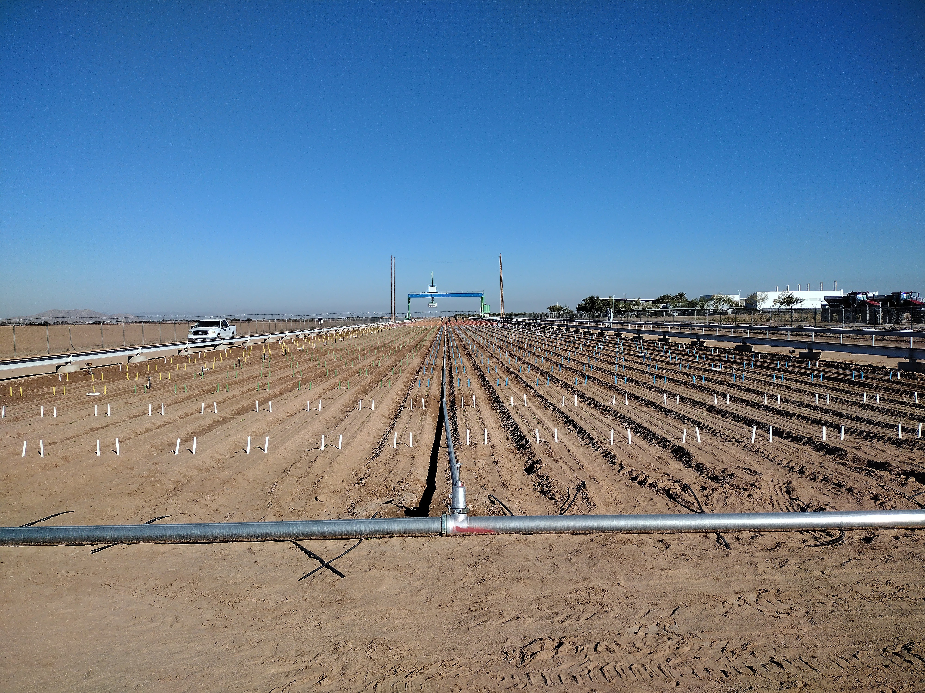

***Figure 1:*** *South gantry lettuce field with shaped raised beds, sprinkler irrigation, and strings and stakes.*

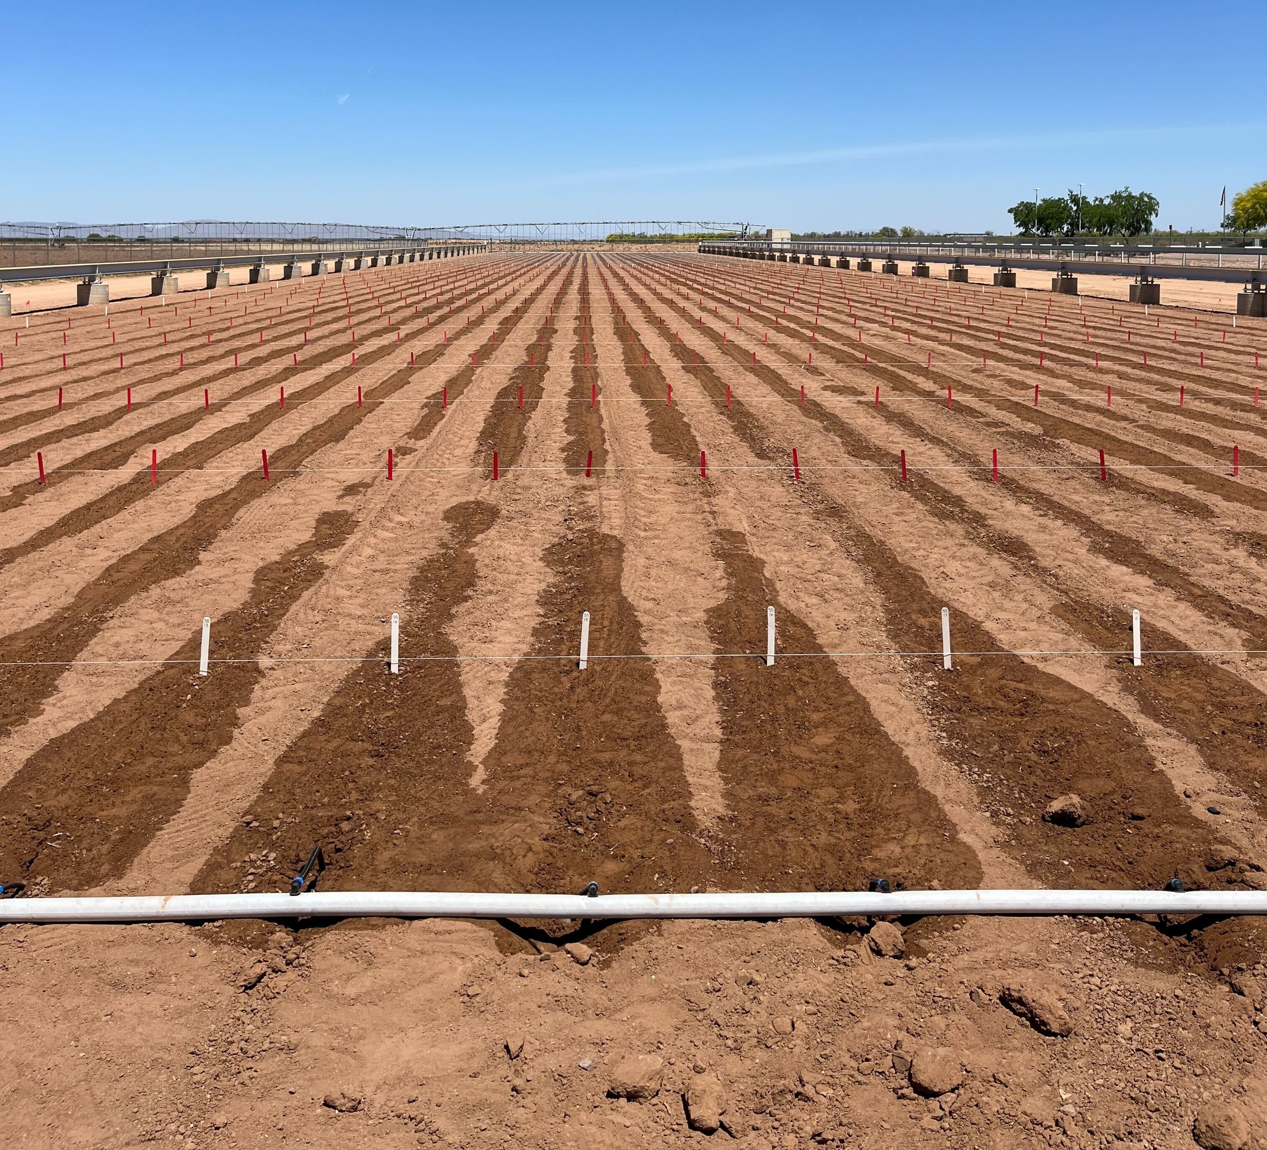

***Figure 2:*** *North gantry sorghum field with strings and stakes.*

**S13, DOP: 2021−12−02**

20

20

20

**S15, DOP: 2022−11−15**

**S17, DOP: 2023−11−14**

Nov 01 Dec 01

Mean air temperature (C)

5

10

5

10

5

10

Nov 01 Dec 01

Nov 01 Dec 01

15

15

15

***Figure 3:*** *Mean air temperature data collected by The Arizona Meteorologial Network (AZMET) during lettuce field trials. Orange vertical lines represent the day of planting. DOP, day of planting; S13, season 13; S15, season 15; S17, season 17.*

## Planting

### Lettuce Planting

Lettuce planting generally occurs around Mid-November to early-December. The mean air temperature during this time has previously ranged from 10 °C to 22 °C (**Figure** **3**).

* + - 1. **Equipment** Lettuce planting is done by hand using [Earthway garden seed](https://www.earthway.com/product/1001-b-precision-garden-seeder/) [planters](https://www.earthway.com/product/1001-b-precision-garden-seeder/) (**Figure** **4** **Left**). Lettuce seeds must be planted at a depth of 1/8 to 1/4 inch. The planting depth can be set using the adjustable screw at the bottom of the seed planter

- ensure this is set to an acceptable depth throughout planting as it can shift. Also, make sure that the chain is not tangled at the bottom of the planter, as it is meant to cover the soil after the planter penetrates the soil during planting. If the chain is tangled, seeds will not be covered with soil, and thus, may not germinate or be blown/washed away. Prior to using the planters, run a generous amount of graphite powder through the funnel and tube to reduce static that might cause seeds to stick to the tube walls.

The Earthway planters were modified by fitting them with funnels and tubing that allows the user to manually hand-feed the small lettuce seeds instead of using the provided seed container and plates. Planting is carried out by members of the Pauli, Arnold, and Michel- more labs. People are paired up with one person responsible for planting the seeds with the Earthway planter, and the other responsible for ensuring the correct plot numbers are being planted and that the correct seed is provided to the person planting (**Figure** **4** **Right**).

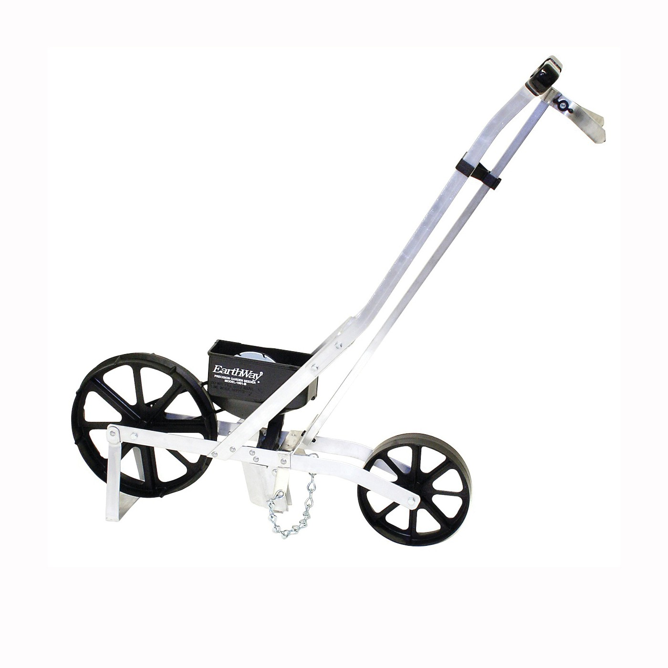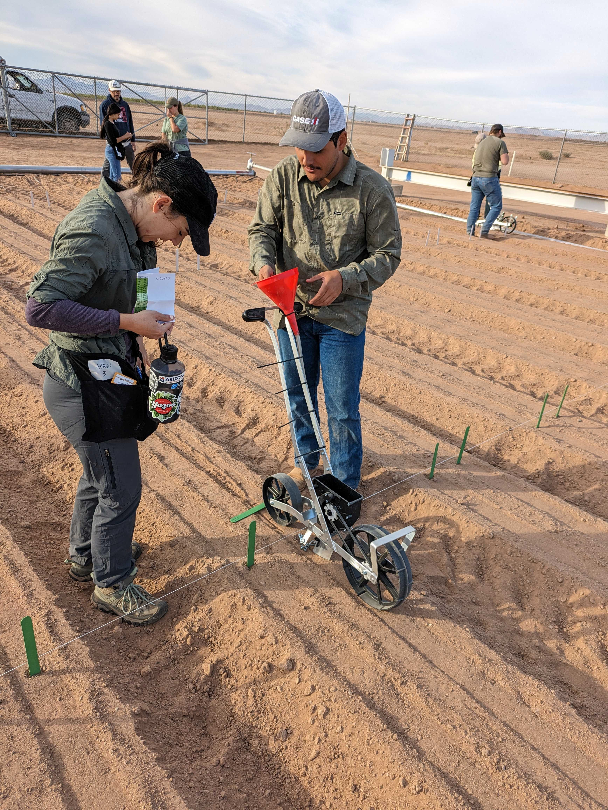

***Figure 4:*** *Lettuce hand planting. (Left) Earthway garden seed planter. (Right) One person planting using the Earthway planter, while the other is responsible for ensuring correct plot numbers and handing the correct seed to the person planting.*

* + - 1. **Potential Issues During Planting** In past years, the tubing that feeds the lettuce seeds into the ground have gotten pinched or otherwise clogged. In these cases, entire columns were inadequately planted - the seed did not make it into the seed line of the expected plot. When this happens, Drs. Duke Pauli and Maria José Truco are notified. The plots within the specific column/s are noted. If seed is not immediately available, Dr. Maria José Truco sends it from Davis, California.

### Sorghum Planting

Sorghum planting generally occurs around early- to mid-April. The mean air temperature during this time has previously ranged from 23 °C to 26 °C (**Figure** **5**).

**S12, DOP: 2021−04−06**

25

30

25

30

25

30

**S14, DOP: 2022−04−20**

**S16, DOP: 2023−04−24**

Apr 05 Apr 19

Mean air temperature (C)

10

15

10

15

10

15

Apr 04 Apr 18

Apr 03 Apr 17 May 01

20

20

20

***Figure 5:*** *Mean air temperature data collected by The Arizona Meteorologial Network (AZMET) during sorghum field trials. Orange vertical lines represent the day of planting. DOP, day of planting; S12, season 12; S14, season 14; S16, season 16.*

* + - 1. **Equipment** Sorghum planting is done by hand using [Easy-Plant jab hand](https://www.johnnyseeds.com/tools-supplies/seeders/jab-planter/easy-plant-jab-type-planter-9178.html?utm_source=google&utm_medium=cpc&utm_campaign=BL%20%7C%20PMax%20%7C%20PRP%20%7C%20HPN%20-%20Smart%20Shopping%20%7C%20All%20Products&gad_source=1&gclid=Cj0KCQiAh8OtBhCQARIsAIkWb6-O2djMwA6ZcjA92P_MQl1rn3f4rC9UEadUIb8rwg2q2QJGVJ-kGGwaAqlGEALw_wcB) [planters](https://www.johnnyseeds.com/tools-supplies/seeders/jab-planter/easy-plant-jab-type-planter-9178.html?utm_source=google&utm_medium=cpc&utm_campaign=BL%20%7C%20PMax%20%7C%20PRP%20%7C%20HPN%20-%20Smart%20Shopping%20%7C%20All%20Products&gad_source=1&gclid=Cj0KCQiAh8OtBhCQARIsAIkWb6-O2djMwA6ZcjA92P_MQl1rn3f4rC9UEadUIb8rwg2q2QJGVJ-kGGwaAqlGEALw_wcB) (**Figure** **6** **Left**). Sorghum seeds must be planted at a depth of 1 inch. Depth of planting is adjusted by moving the seed depth plate. The seed depth plate has a slotted opening with a stud secured by a wing nut. By loosening the wing nut, the seed depth plate

can be moved along the slot. Tightening the wing nut secures the seed depth plate at the specified depth.

Planting is carried out by members of the Pauli and Arnold labs. Each person is responsible for carrying seeds, planting the seed in the correct plot using the spacing guide (PVC pipe, 6- inch markings placed using electrical tape), and gently covering the seed with a light amount of soil after planting (**Figure** **6** **Right**). A total of 20 seeds are planted equidistantly in each plot, using the spacing guide (PVC pipe). The first seed should be 6 inches away from the plot stake. It is important that the soil placed on top of the seed not be compacted too much, otherwise seeds will not germinate. Lightly tap on the seed after lightly covering it with soil, but do not forcefully step on it with your boots!

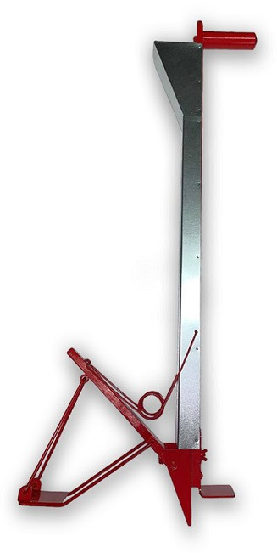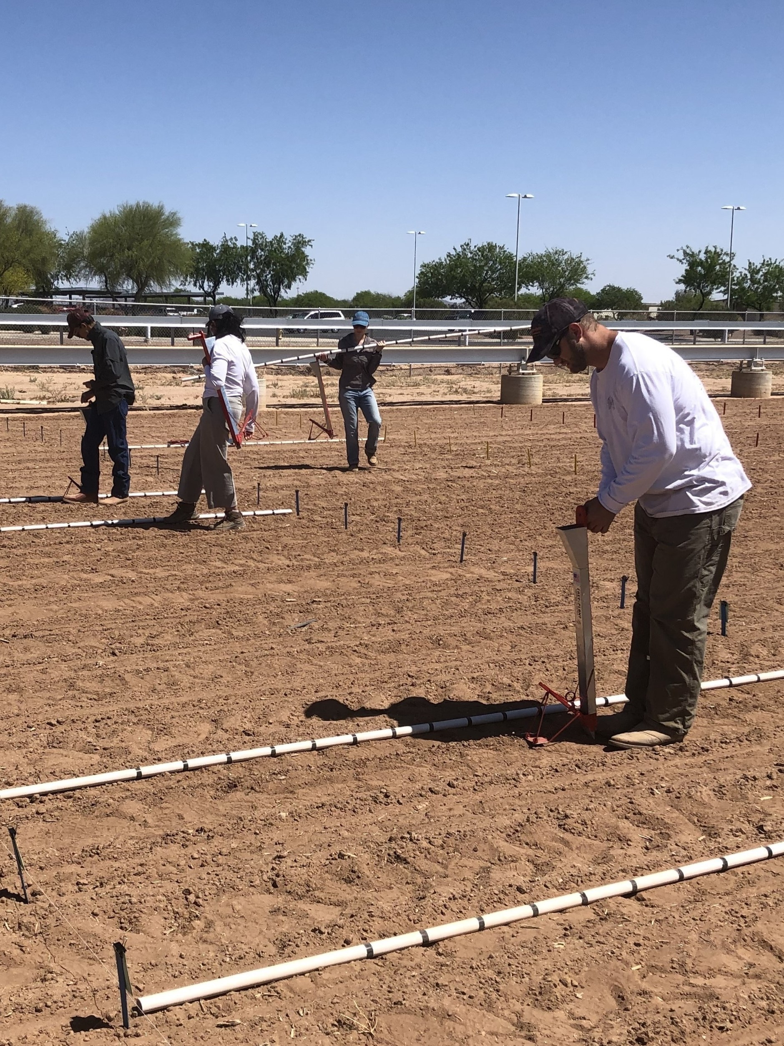

***Figure 6:*** *Sorghum hand planting. (Left) Easy-Plant jab hand planters used for sorghum planting. (Right) Lab member using the Easy-Plant jab hand planter.*

* + - 1. **Potential Issues During Planting** In past years, too much soil compaction has led to seeds not germinating. To avoid this, ensure that you do not forcefully step on the seed after covering it with soil. It is best to very gently tap the soil placed on top of the seed with your boots.

The wing nut securing the seed depth plate can loosen after a few hours of use. The force of jabbing the planter causes vibrations that can eventually cause the wing nut to fall off. Ensure that you are constantly checking this wing nut after 2-3 ranges. To ensure a consistent planting depth, check the seed depth plate with the depth guide (piece of cardboard) after 2-3 ranges. If the seed depth plate has shifted, readjust to a 1-inch depth.

The hex screws holding all other components of the jab planter can loosen. To ensure that the jab planter functions normally, check all hex screws on the jab planter after 2-3 ranges.

## Ground Control Points

The raw data collected by the Field Scanalyzer has a high level of misalignment of images and point clouds. To mitigate this error, a high number of ground control points (GCPs) are placed in the field during lettuce and sorghum field trials. These GCPs include (**Figure** **7**):

* White plastic bucket lids, four columns into the field on both east and west ends. Located in the alleys of the plot without puncturing the drip tape.
* Umbrella holders with grey metal bucket lids, furrow between four and five columns into the field on both east and west ends

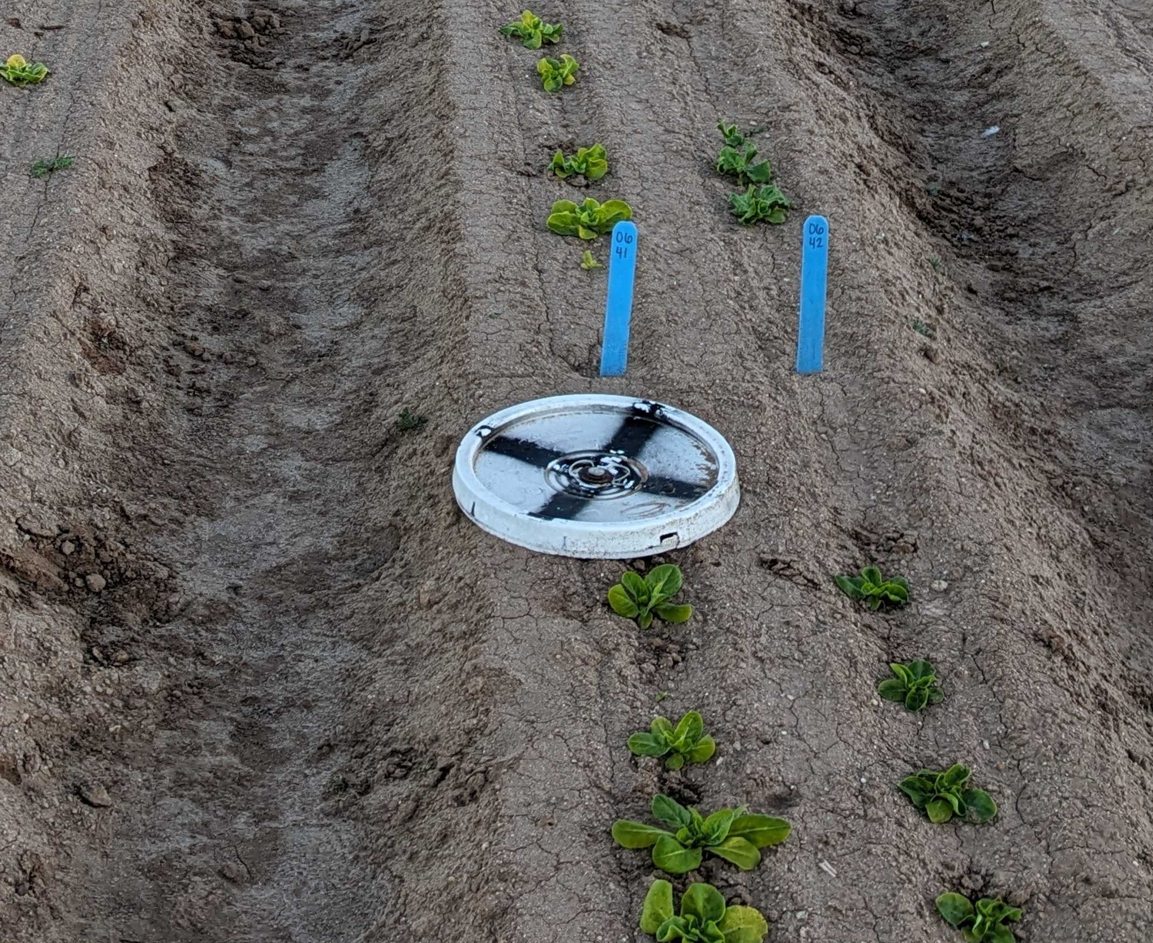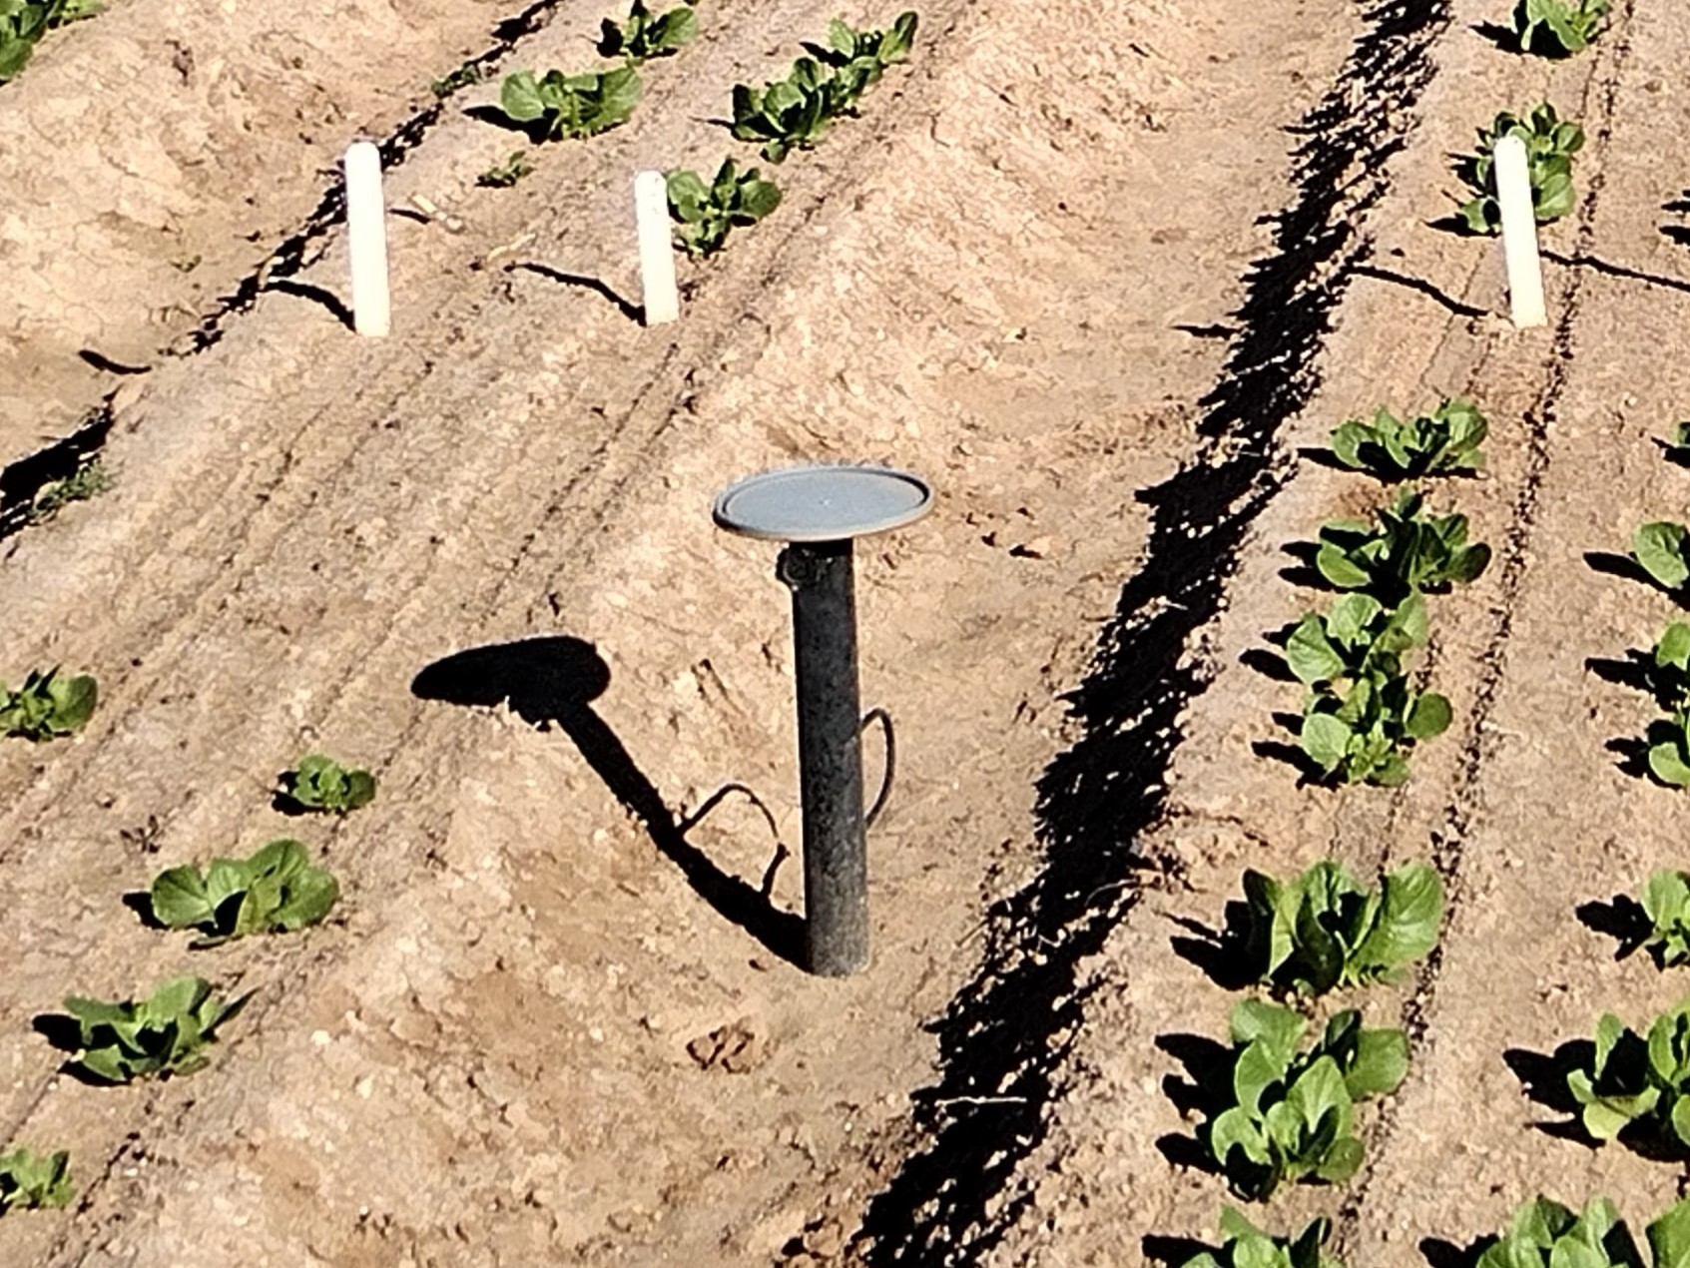

***Figure 7:*** *Ground control points (GCPs) used in the gantry field. (Left) White plastic bucket lid. (Right) Umbrella holder with grey metal bucket lid.*

Each range contains a single white plastic bucket lid and two umbrella holders with grey metal bucket lids in the following arrangement for both lettuce and sorghum field trials (**Figure** **8**):

## Thinning

### Lettuce Thinning

Thinning is a very important part of the lettuce field trial as the planters often result in clusters of seeds germinating close to each other. Thinning is conducted in two phases (**Figure** **9**):

* Phase 1: Thin the plots to achieve 6-inch spacing between plants (results in ~20 plants per plot)

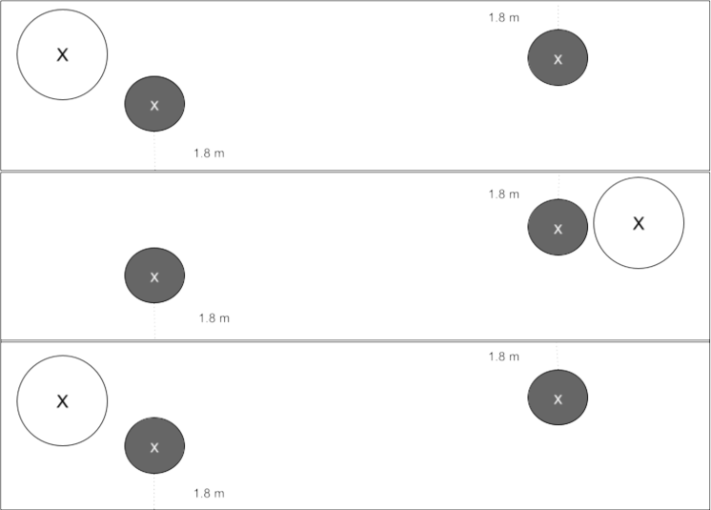 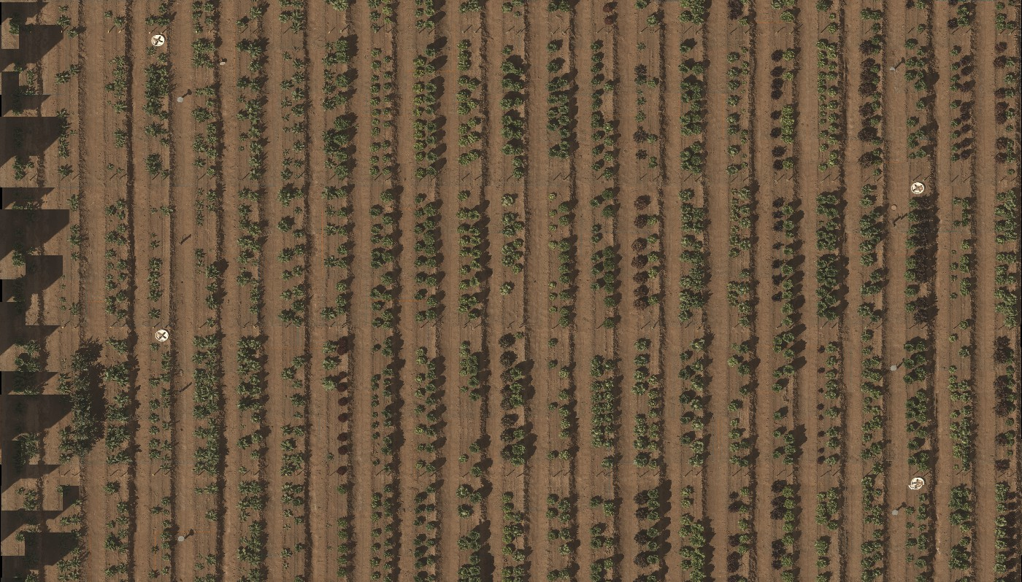

***Figure 8:*** *Arrangement of ground control points (GCPs) in the gantry field. (Left) Each range contains a single white plastic bucket lid and two umbrella holders with grey metal bucket lids. (Right) White plastic bucket lids are alternated, to ensure robust geocorrection.*

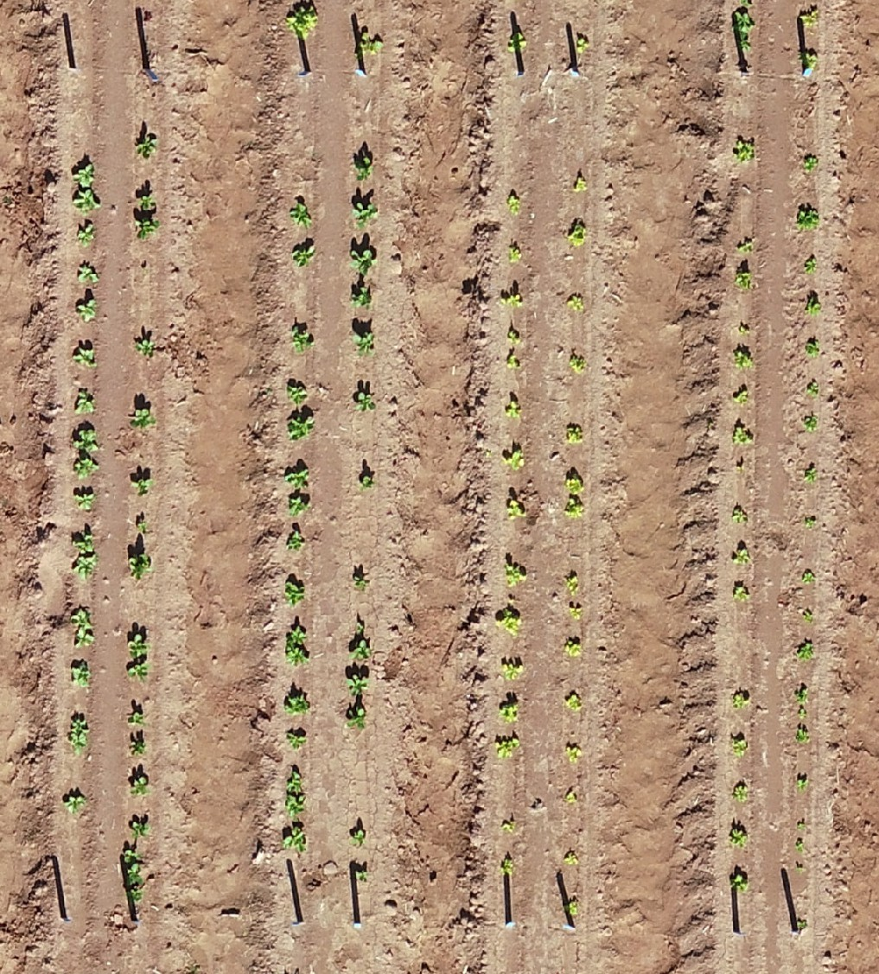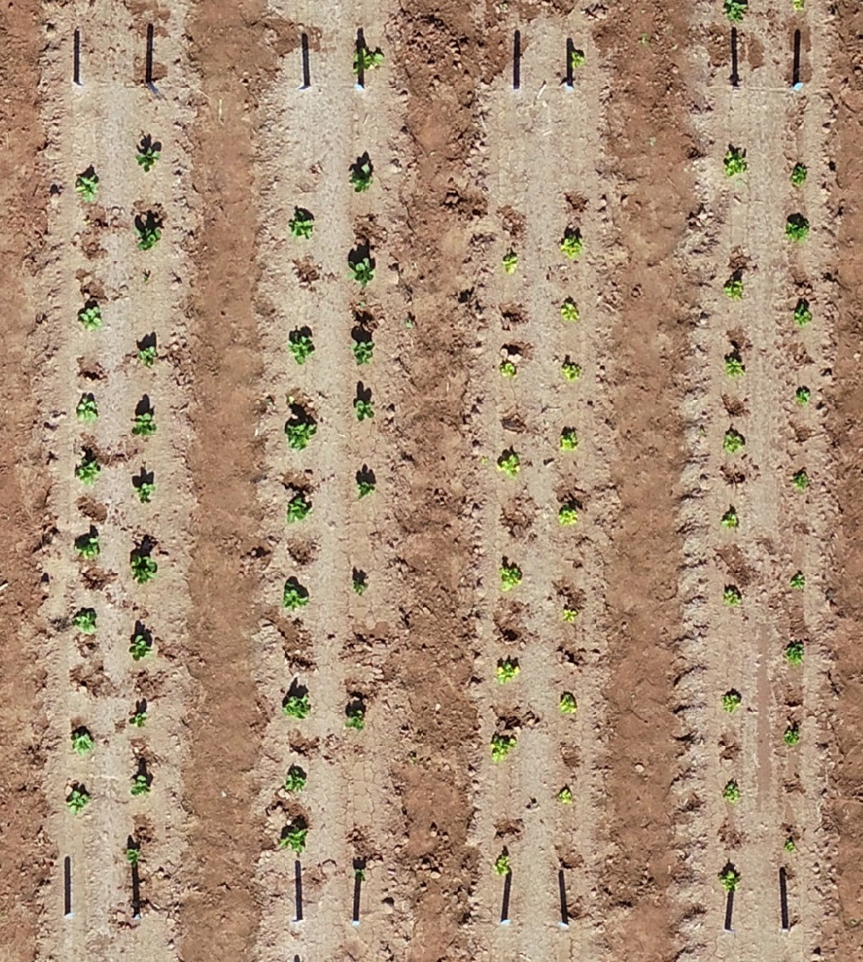

***Figure 9:*** *Change in plant density after multiple rounds of thinning. (Left) Plants after Phase 1 of thinning. (Right) Plants after Phase 2 of thinning.*

* Phase 2: Thin the plots to achieve 12-inch spacing between the plants (results in ~10 plants per plot), with the goal of staggering plants between plots

The 10 individual lettuce plants resulting from Phase 2 should be equidistant. The equidis- tant placement reduces any overlap with neighboring plants. This is an important step as the goal with the Field Scanalyzer data is to phenotype each plant individually. The farther plants are, the easier it is to individually phenotype them.

### Sorghum Thinning

Thinning is a very important part of the sorghum field trial as leaf overlap between plants increases as plants grow, making it hard to computationally phenotype individual plants. Sorghum thinning is a single phase (**Figure** **10**):

* Phase 1: Thin the plots to achieve 28-inch (~ 70 cm) spacing between plants (results in ~5 plants per plot)

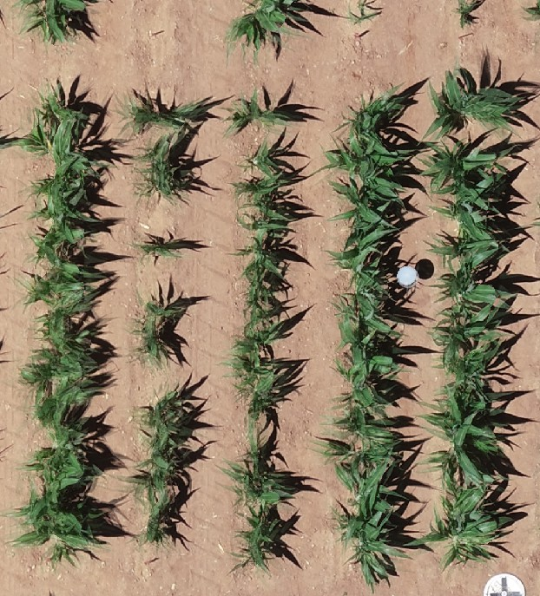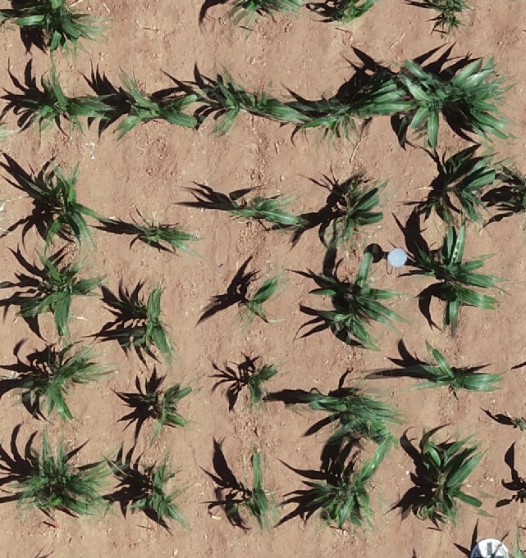

***Figure 10:*** *Change in sorghum plant density after thinning. (Left) Plant growth about 1.5 months after planting. (Right) Plants after Phase 1 of thinning.*

The 5 individual sorghum plants resulting from Phase 1 should be equidistant. The equidis- tant placement reduces any overlap with neighboring plants. This is an important step as the goal with the Field Scanalyzer data is to phenotype each plant individually. The farther plants are, the easier it is to individually phenotype them.

## Positioning Information Preparation

The Global Positioning System (GPS) coordinates of each GCP must be collected so they can be used in PhytoOracle workflows. To accomplish this, you need a Trimble Global Navigation Satellite System (GNSS) (**Figure** **11**).

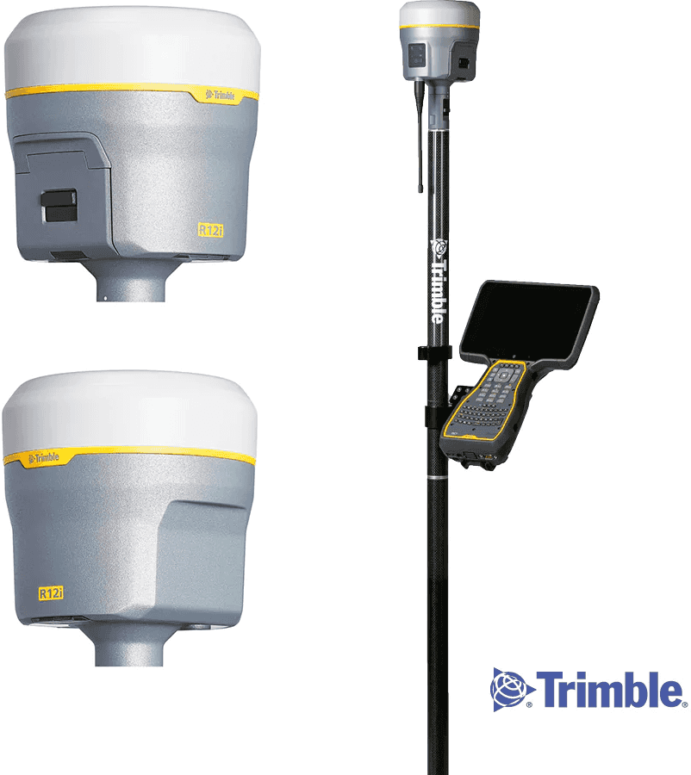

***Figure 11:*** *Trimble Global Navigation Satellite System (GNSS) used to collect accurate Global Positioning System (GPS) coordinates of Ground Control Points (GCPs).*

### Collecting Global Positioning System (GPS) Coordinates

The United States Department of Agriculture (USDA) Arid Land Agricultural Research Center (ALARC) has trimbles that we can borrow. To use them, follow the steps below:

1. Run Trimble Access - Press Trimble hard key (Windows symbol), select Trimble Access
2. Log in — Click either “Tap here to log in” or the current logged in person (e.g., kelly.thorp)
   * Login Mode: Offline
   * Select your user name.
     + If you already have a username, select it…click next…click finish
     + Else type in your user name…Click finish
     + Passwords are optional…be professional
3. Set up a job - Click General Survey -> Jobs
   * If opening existing job, click “Open job” then select the job
   * If starting a new job, click “New job” then
     + Job name: Give the job a name.
     + Template: Default
     + Coord sys.: Click ‘Select from library’

∗ System: ‘World wide/UTM’

∗ Zone: 12 North

∗ Datum: WGS 1984 (7P)

∗ Project height: 361m

* + - Click Store Accept
  + If using the Yuma 2 and the Bluetooth needs connected
    - Turn on the GNSS receiver
    - General Survey -> Instrument -> GNSS Functions Bluetooth

∗ Under ‘Connect to GNSS Rover’ select: R8s, Serial#: Trimble

∗ Save/Accept

1. To measure points
   * Go to field. Click General Survey -> Measure -> ALARCRTK -> Measure points
   * Accept base station.
   * Point name: Name the point. (If you put a number at the end, it will auto-increment.)
   * Code: Add optional additional info.
   * Method: Rapid point
   * Antenna height (Uncorr): 2.000m
   * Vertical offset: 30.839m Up (This is important to get the Z coordinate correct.)
   * Click “Measure” to record a point.
   * Go to lab. Connect TSC3 to computer.
   * Click General Survey -> Jobs -> Import/Export -> Export fixed format -> Accept

-> All points

* + Copy the file off the TSC3:
    - “This PC\Trimble Navigation Limited TSC3\\Export”

1. To stake flags at point locations
   * Copy CSV file to the TSC3
     + Save CSV from Excel to help TSC3 recognize points. Do not add header line.
     + Order: Point name, Northing, Easting, Elevation, Code (optional)
     + Connect TSC3 to computer and copy point file to your user directory.

∗ “This PC\Trimble Navigation Limited TSC3\”

* + Go to field. Click General Survey -> Stakeout -> ALARCRTK -> Points - Remove points from old stakeouts, if they exist. - Add -> Select from file -> choose point file.

- Click ‘All’ - Click Add - Select a point, then select StakeoUt Navigate to the point, and stake flag.



***Table 1:*** *Ground Control Point (GCP) coordinate file. Each row represents the coordinate of a single GCP.*

|  |  |  |  |  |
| --- | --- | --- | --- | --- |
| GCP | Type | Northing | Easting | Height..m. |
| plate1 | White | 3659979 | 408992.8 | 360.775 |
| plate2 | White | 3659987 | 408992.9 | 360.788 |
| plate3 | White | 3659995 | 408992.9 | 360.783 |
| plate4 | White | 3660003 | 408993.0 | 360.770 |
| plate5 | White | 3660011 | 408993.1 | 360.775 |
| plate6 | White | 3660019 | 408993.1 | 360.765 |

# Pipeline Preparation

The PhytoOracle (PO) pipelines require GCP and GeoJSON files. Additionally, a Yet Another Markup Language (YAML) file is used by PO for automated, reproducible data processing. YAMLs are a form of a configuration file that can be used to define a series of arguments/flags. The details of the YAML files can be found on our [PhytoOracle Automa-](https://github.com/phytooracle/automation/blob/main/docs/yaml.md) [tion repository](https://github.com/phytooracle/automation/blob/main/docs/yaml.md).

## Positioning Information Files Required by PhytoOracle

PhytoOracle relies on geospatial information, such as GPS coordinates, to accurately link phenotypes with a location in the field. This allows us to detect, tag, and track individual plants over the course of multiple Field Scanalyzer scans. Specifically, PhytoOracle requires two files:

1. GCP file: Text file containing the GPS coordinates of all field GCPs.
2. GeoJSON: File containing polygons representing each plot in the gantry field

These files must be generated prior to data processing for the respective season. Additionally, these files should be loaded onto [QGIS](https://qgis.org/en/site/) for visual inspection and confirmation that the coordinates are accurate.

### Generating GCP File

The Trimble collects GPS coordinates in the Easting, Northing format (Table 1). Phy- toOracle requires GPS coordinates to be in the latitude, longitude format. To convert the coordinates, use the [gcp_coordinates_conversion repository](https://github.com/phytooracle/gcp_coordinates_conversion) to use the conversion tool. Af- ter running the conversion script, the data will now be in the required latitude, longitude format (Table 2).

***Table 2:*** *Ground Control Point (GCP) coordinate file. Each row represents the coordinate of a single GCP.*

|  |  |  |
| --- | --- | --- |
| GCP number | Latitude | Longitude |
| 1 | 33.07470 | -111.975 |
| 2 | 33.07478 | -111.975 |
| 3 | 33.07485 | -111.975 |
| 4 | 33.07492 | -111.975 |
| 5 | 33.07499 | -111.975 |
| 6 | 33.07506 | -111.975 |

### Generating GeoJSON File

GeoJSON files contain polygons that represent each plot in the gantry field (**Figure** **12**). These polygons are used to extract smaller experimental units from larger units, such as the full field scale.

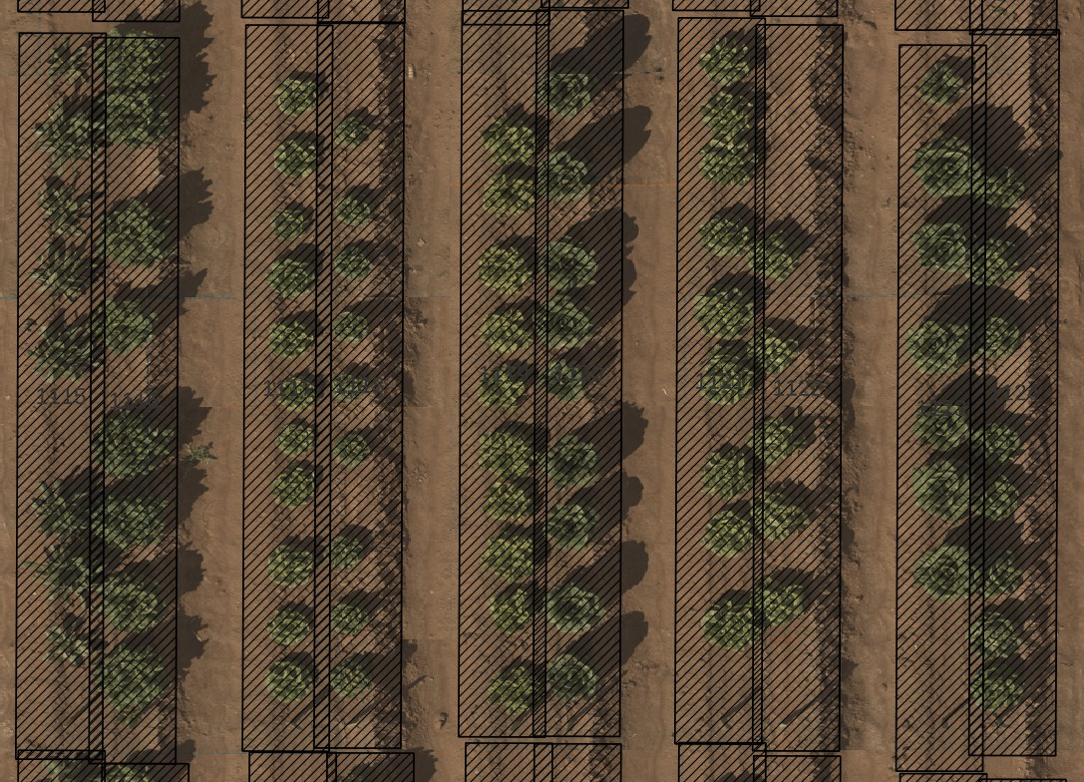

***Figure 12:*** *GeoJSON file containing a single polygon for each plot.*

Our field design and dimensions remain pretty consistent from one season to the next. As a result, existing GeoJSONs are modified and applied to new seasons. In the case that a new GeoJSON needs to be created, please refer to [FIELDimageR](https://github.com/OpenDroneMap/FIELDimageR?tab=readme-ov-file&p5).

If you are editing a pre-existing GeoJSON, you will need to:

1. Move polygons that are misaligned in the new season
2. Rename genotype column
   * + 1. **Moving polygons** To move polygons, you need to load the GeoJSON and a drone orthomosaic onto QGIS. Then, you can follow the steps in **Figure** **13**:
          1. Click “Toggle Editing”
          2. Click “Select Features by Area or Single Click”
          3. Click “Move Features”
          4. Manually move polygon into desired alignment
          5. Single click to drop the polygon into the desired location
          6. Save changes

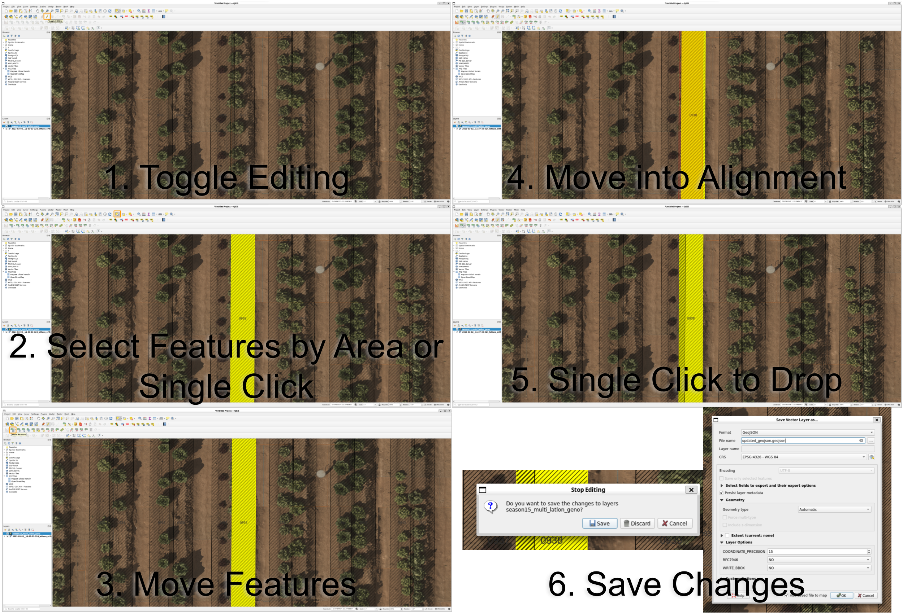

***Figure 13:*** *Editing GeoJSON polygons using QGIS.*

* + - 1. **Renaming genotype column** The “genotype” values in the GeoJSON file can be edited using [GeoPandas](https://geopandas.org/en/stable/). A GeoJSON can be opened up as a dataframe, similar to [Pandas](https://pandas.pydata.org/). Once opened, you can then replace the “genotype” columns using the fieldbook for the respective season. To see an example [click here](https://github.com/phytooracle/correct_plot_information).

## Editing YAML file

For each season, YAML files must be edited to correctly process data for the respective season.

Specifically, the following keys should be edited for each season:

* tags
  + pipeline
  + season
  + season_name
* workload_manager
  + manager_name
* paths
  + cyverse

∗ input

· necessary_files

Examples of YAMLs for each season can be found [here](https://github.com/phytooracle/automation/tree/main/yaml_files).

## Updating GitHub Repositories

### PhytoOracle Data

At the start of a new season, updates must be made to the phytooracle_automation repos- itory to capture necessary information in the [season_config_yaml variable](https://github.com/phytooracle/phytooracle_data/blob/3e780d8b5c5c5a8515f6dfcd0ec60347d57d8319/phytooracle_data/seasons.py#L11).

The season is defined by multiple keys, including name, start_date, end_date, flir_temp_units, and complete_field_dates (**Figure** **14**).

Below are some details for each key:

* name: Season name, as it shows up on the CyVerse DataStore
* start_date: Date of planting
* end_date: Date of harvest
* flir_temp_units: Temperature units reported by thermal (FLIR) images
* complete_field_dates: List of RGB scan dates

To get a list of RGB dates, use iRODS to ils the directory of the respective season (**Figure** **15**).

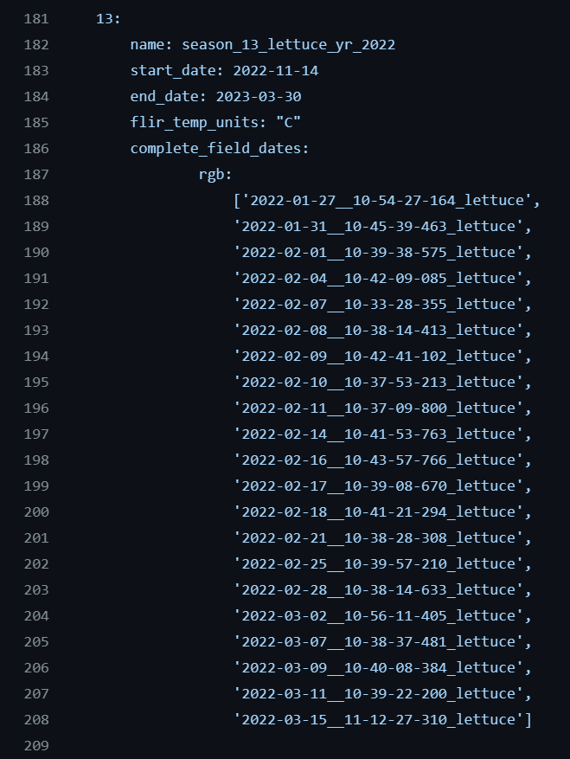

***Figure 14:*** *Section of the season_config_yaml variable in the phytooracle_data GitHub repository.*

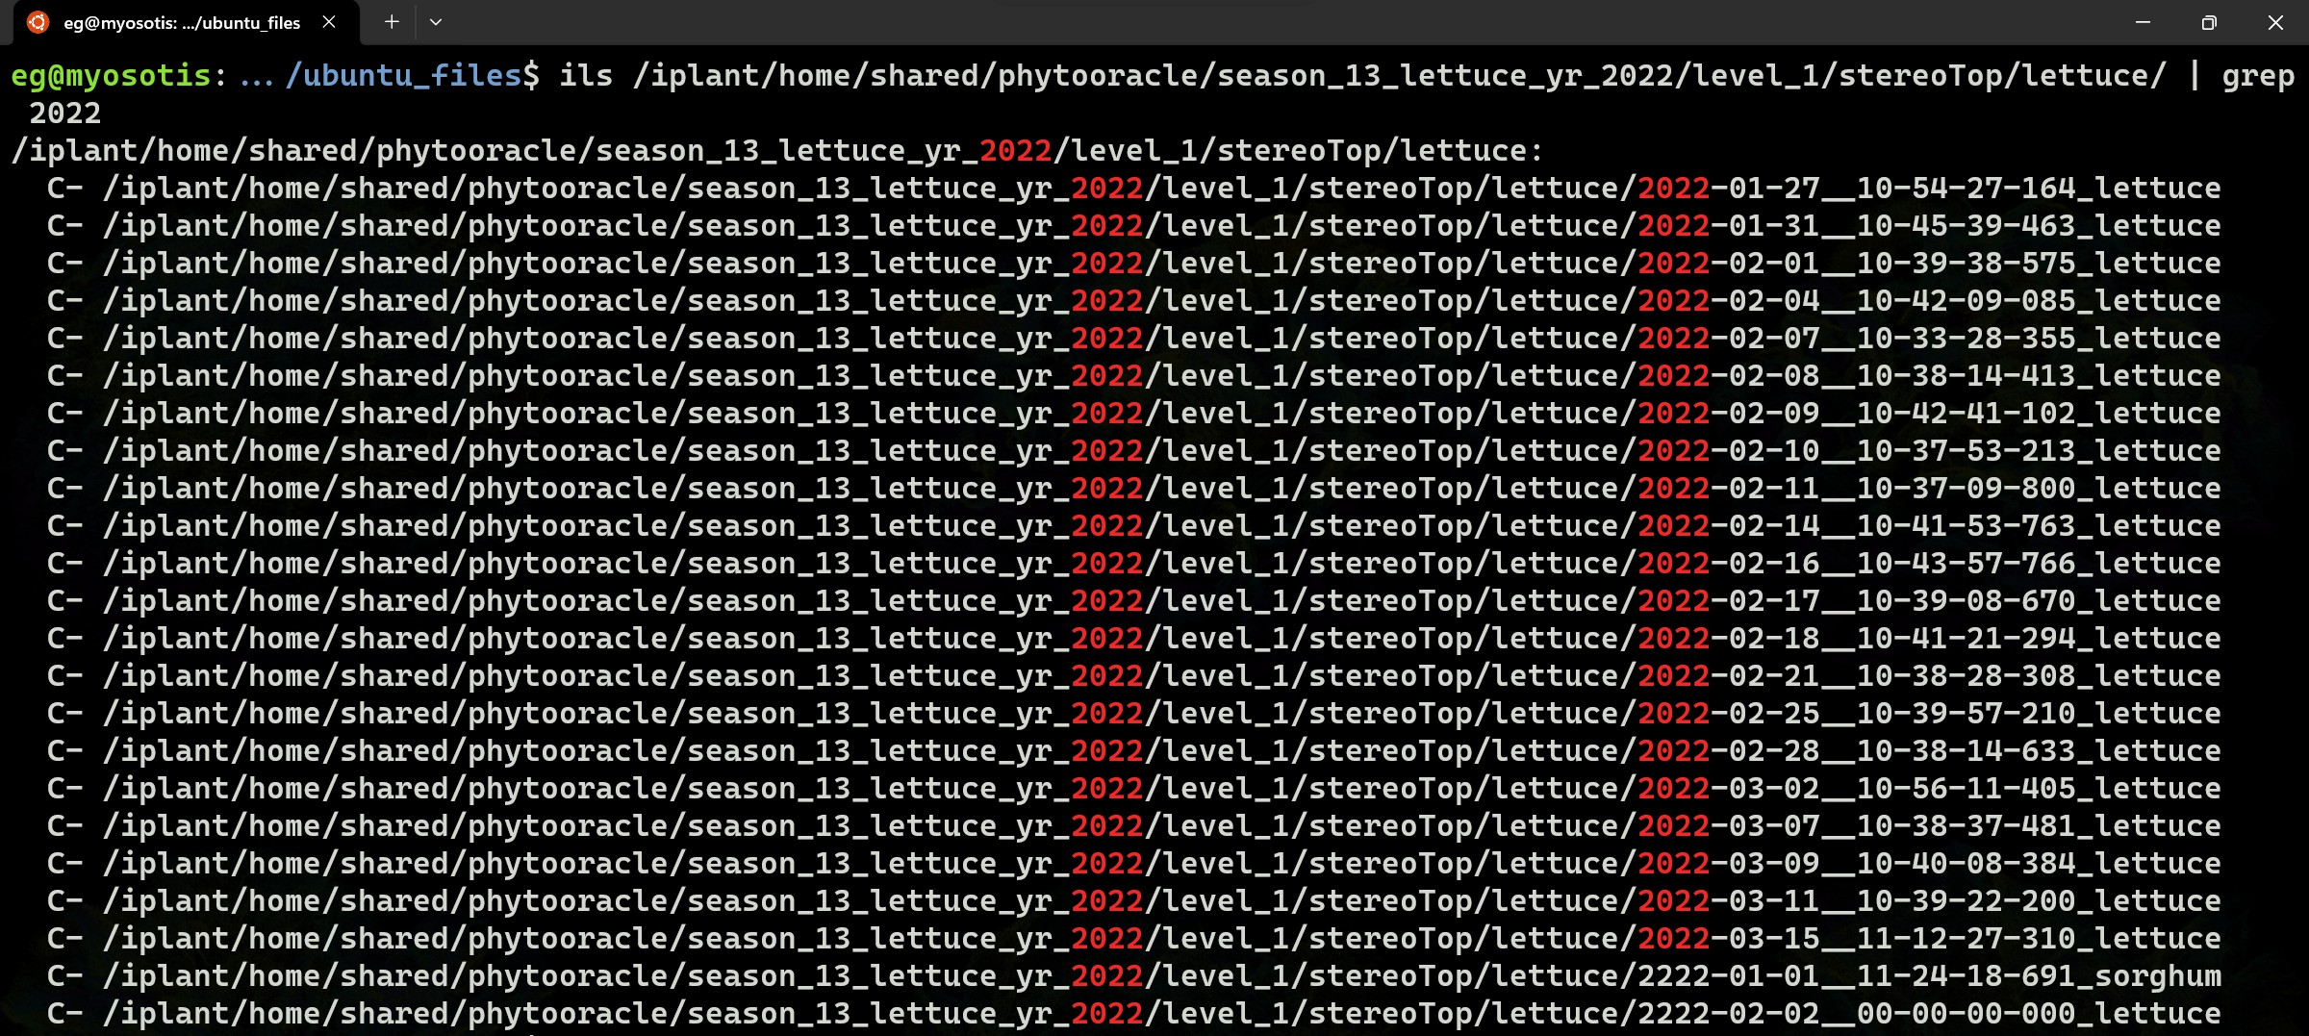

***Figure 15:*** *Getting RGB dates using iRODS.*

### PhytoOracle Landmark Selection

The PhytoOracle [3d_landmark_selection](https://github.com/phytooracle/3d_landmark_selection) contains the phytooracle_data repository. As such, the [3d_landmark_selection container on DockerHub](https://hub.docker.com/repository/docker/phytooracle/3d_landmark_selection/builds) must be rebuilt once the above- mentioned changes have been made to the phytooracle_data repository. To accomplish this, log into an account with appropriate permissions, then click on “Trigger” for the “latest” container (**Figure** **16**).

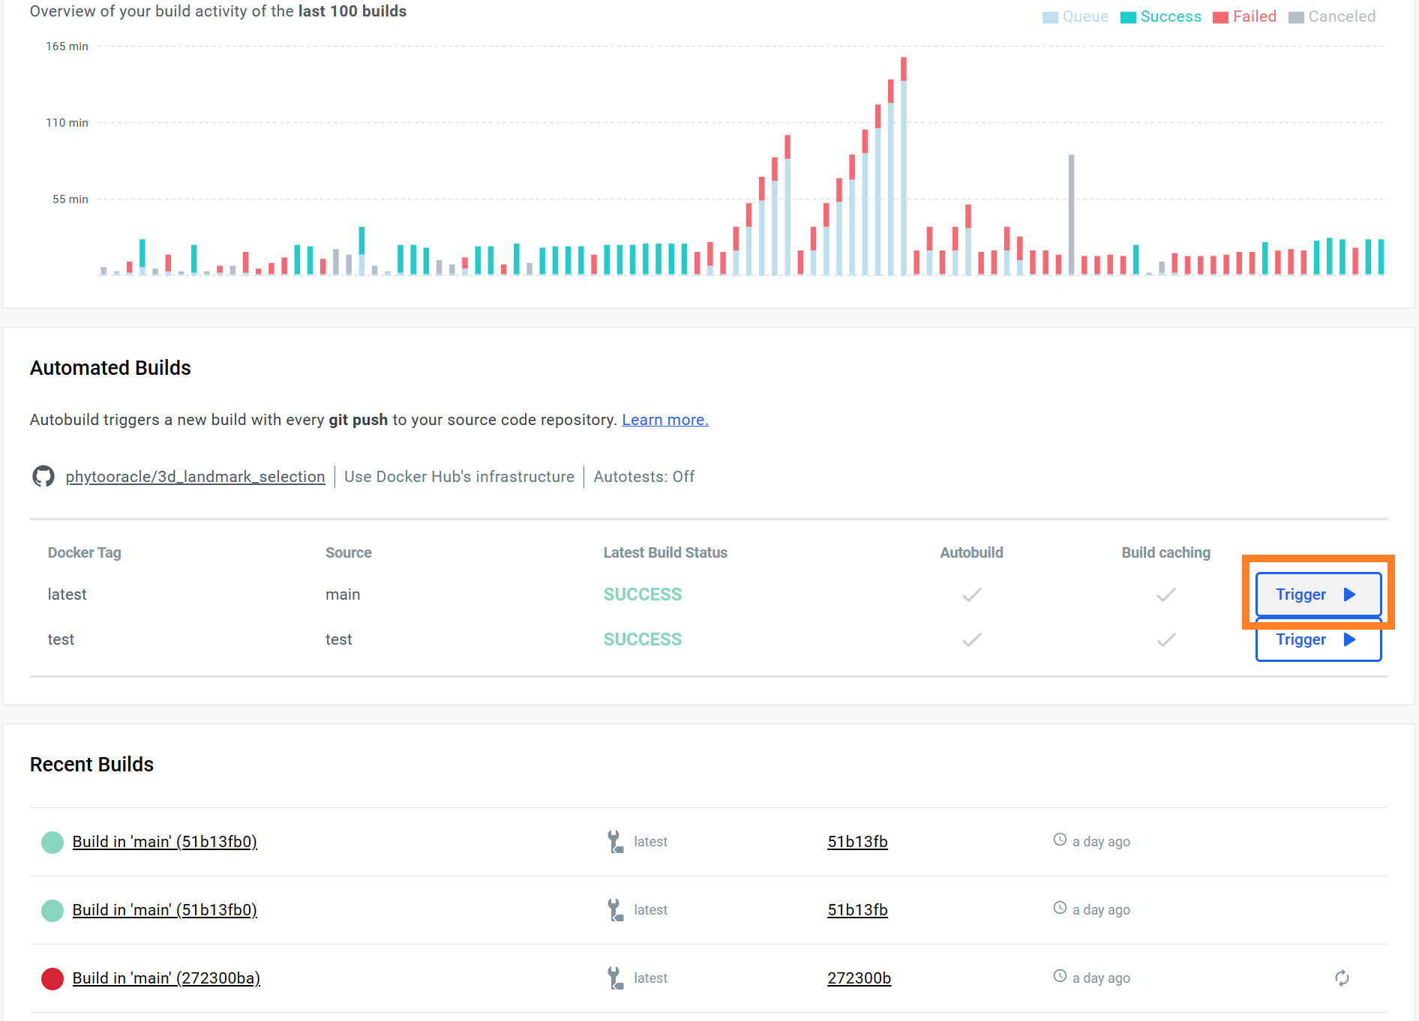

***Figure 16:*** *Rebuilding the* 3𝑑*_*𝑙𝑎𝑛𝑑𝑚𝑎𝑟𝑘*_*𝑠𝑒𝑙𝑒𝑐𝑡𝑖𝑜𝑛 *container on DockerHub.*

# Intro to High Performance Computers

## UArizona High Performance Computing Cluster

The University of Arizona maintains a High Performance Computing (HPC) center, which houses three compute resources: El Gato, Ocelote, and Puma.

### Compute System

**Name El Gato Ocelote Puma**

***Model*** IBM System X iDataPlex dx360 M4

Lenovo NeXtScale nx360 M5

Penguin Altus XE2242

***Node Count*** 131 400 236 CPU-only, 8

GPU, 2

high-memory

#### *Total System* Memory (TB)

26TB 82.6TB 128TB

#### *Cores / Node* (schedulable)

16c 28c (48c -

High-memory node)

94c

***Total Cores*** 2160* 11528* 23616*

***Processor Speed*** 2.66GHz 2.3GHz (2.4GHz -

Broadwell CPUs)

2.4GHz

***Memory / Node*** 256GB - GPU

nodes, 64GB - CPU-only nodes

192GB (2TB -

High-memory node)

512GB (3TB -

High-memory nodes)

***GPU accelerators*** 46 NVIDIA P100 (16GB)

29 NVIDIA V100S

***OS*** Centos 7 CentOS 7 CentOS 7

### Compute Resources

The UArizona HPC provides three types of resources:

* Windfall: Unlimited, can be preempted
* Standard: Limited, no preemption
  + El Gato: 7,000 CPU-hours per month
  + Ocelote: 70,000 CPU-hours per month
  + Puma: 100,000 CPU-hours per month
* High Priority:
  + Puma

∗ ericlyons: 175,200 CPU-hours per month

∗ dukepauli: 35,040 CPU-hours per month

*Note: High priority is only available for the Puma cluster.

### Further Information

Further information on the UArizona HPC is available in the [HPC Documentation](https://uarizona.atlassian.net/wiki/spaces/UAHPC/overview).

# Running PhytoOracle on High Performance Com- puters

PhytoOracle is a scalable, modular phenomics data processing workflow manager. In short, this means that PhytoOracle can leverage HPC clusters and cloud computing to distribute tasks across hundreds to thousands of cores.

## Defining Compute Resources

Resources are defined in the workload_manager section of the PhytoOracle YAML. In this section, you can define many compute resource settings. Below is an example:

* account: ericlyons
* high_priority_settings:
  + use: True
  + qos_group: user_qos_ericlyons
  + partition: high_priority
* standard_settings:
  + use: False
  + partition: standard
* job_name: phytooracle_worker_rgb
* nodes: 1
* number_worker_array: 490
* cores_per_worker: 1
* time_minutes: 720
* retries: 1
* port: 0
* mem_per_core: 5
* manager_name: stereoTop_level01_s15
* worker_timeout_seconds: 43200

## Before Deploying PhytoOracle

There are a few things you must ensure before deploying PhytoOracle:

* Confirm existence and accuracy of GCP file. Visually inspect using GIS software (e.g., QGIS), confirming correct placement of GCPs by overlaying the points with an RGB orthomosaic, either drone or gantry.
* Confirm existence and accuracy of GeoJSON file. Visually inspect using GIS software (e.g., QGIS), checking plot number sequence and genotype values.

If these steps are not followed, errors can propagate to multiple levels of data processing, requiring a reprocessing of data.

## Supported Data Types

The Field Scanner collects two-dimensional (2D) and three-dimensional (3D) data types, including scannerTop3D (3D), stereoTop (RGB), ps2Top (fluorescence), and flirIrCamera (thermal) (**Figure** **17**).

### 2D Field Scanner Data Types

The 2D data collected by the Field Scanner includes stereoTop (RGB), flirIrCamera (ther- mal), and ps2Top (fluorescence). These data process relatively quickly as they are much lower in size compared to 3-dimensional (3D) data. The processing of 2D data types is fully developed for both lettuce and sorghum (**Figure** **18**).

### 3D Field Scanner Data Types

The major goal of the PhytoOracle project is to phentoype individual plants at a high spatial-temporal scale. To accomplish this, individual plant positioning information (GPS coordinates) collected during 2D data processing are leveraged to extract data from 3D data (**Figure** **19**).

As such, much focus has been placed on 3D point cloud data. These data undergo intensive processing to extract individual plant point clouds (**Figure** **20**).

## Deploying PhytoOracle

After (*i*) checking the GCP and GeoJSON files (Section 4.2) and (*ii*) generating a YAML file (Section 2.2), you are now ready to run PhytoOracle.

PhytoOracle is made up of multiple workflows to process 2D and 3D data (**Figure** **21**). These workflows allow for automated, scalable processing of raw data collected by the Field Scanner. The data processing results in high spatial-temporal phenotype information.

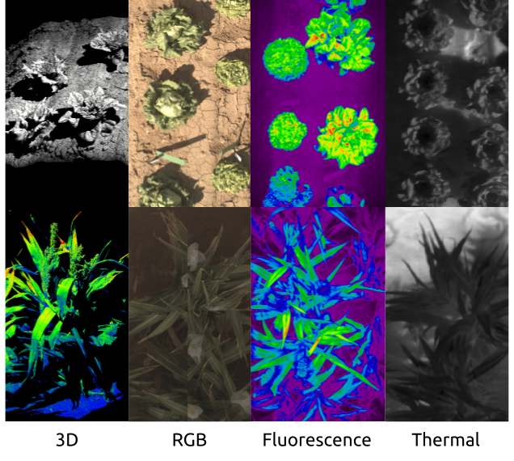

***Figure 17:*** *Data types collected by the Field Scanner. Two-dimensional (2D) data types include RGB, fluorescence, and thermal images, while three-dimensional (3D) include 3D point clouds.*

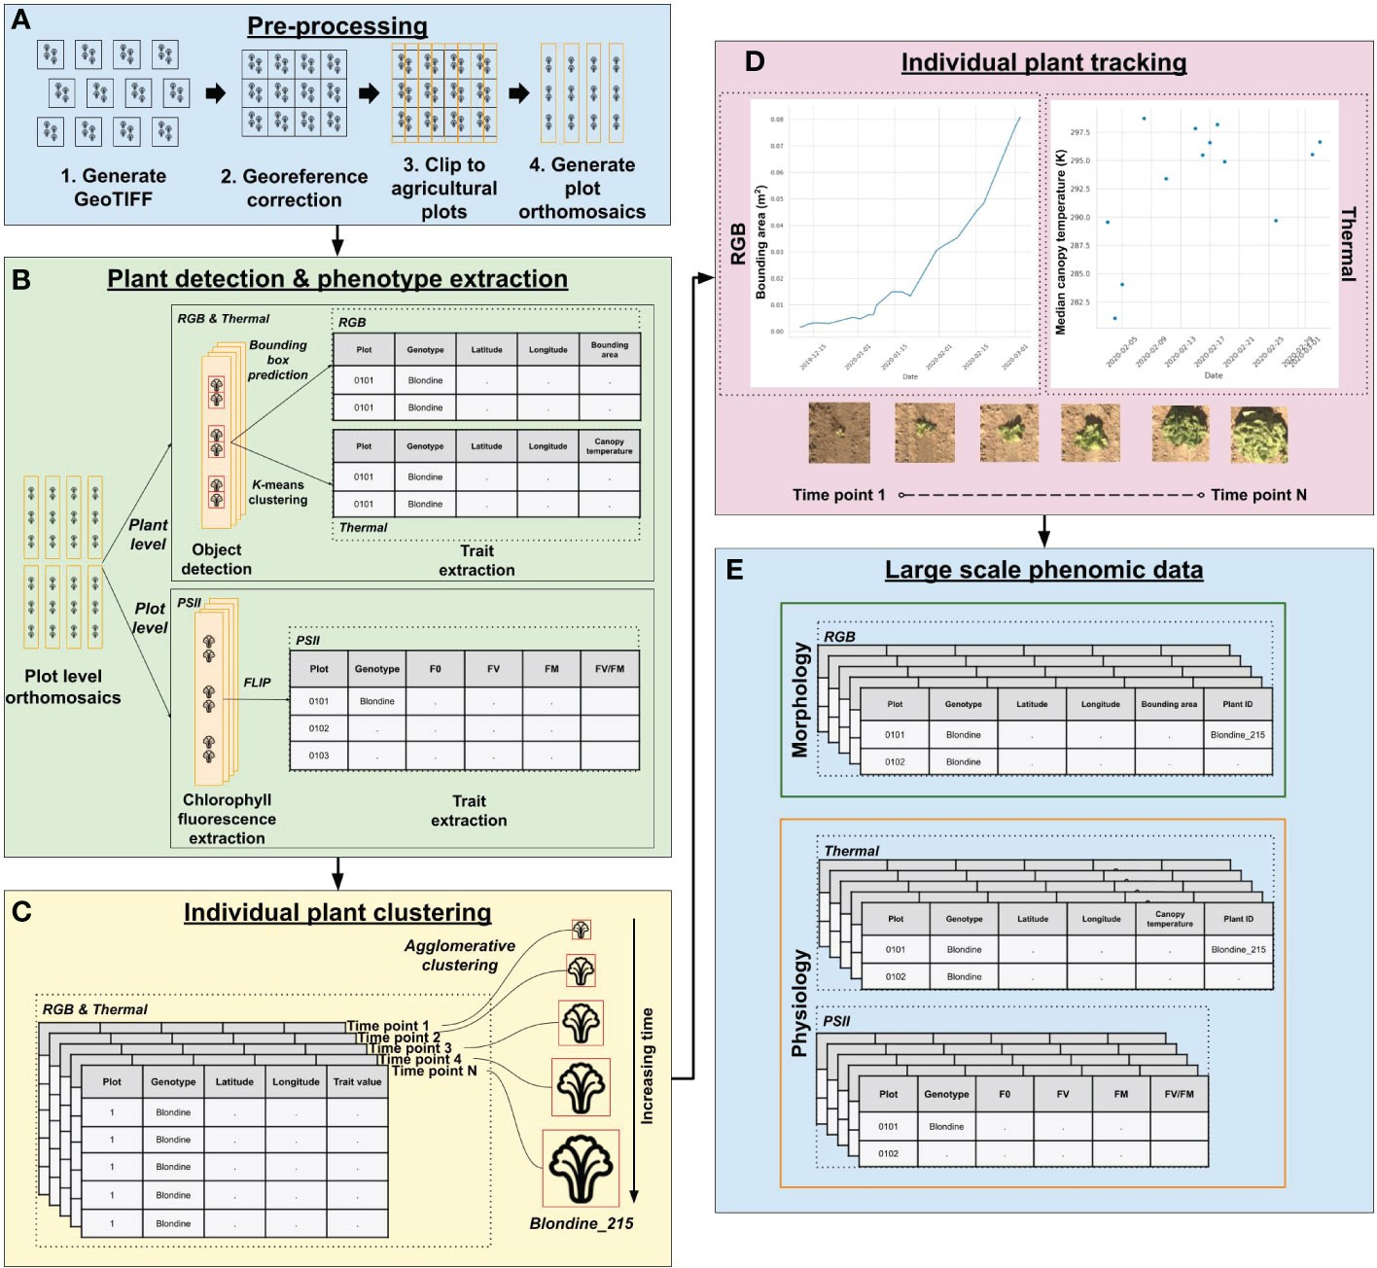

***Figure 18:*** *Visualization of 2D data processing by PhytoOracle.*

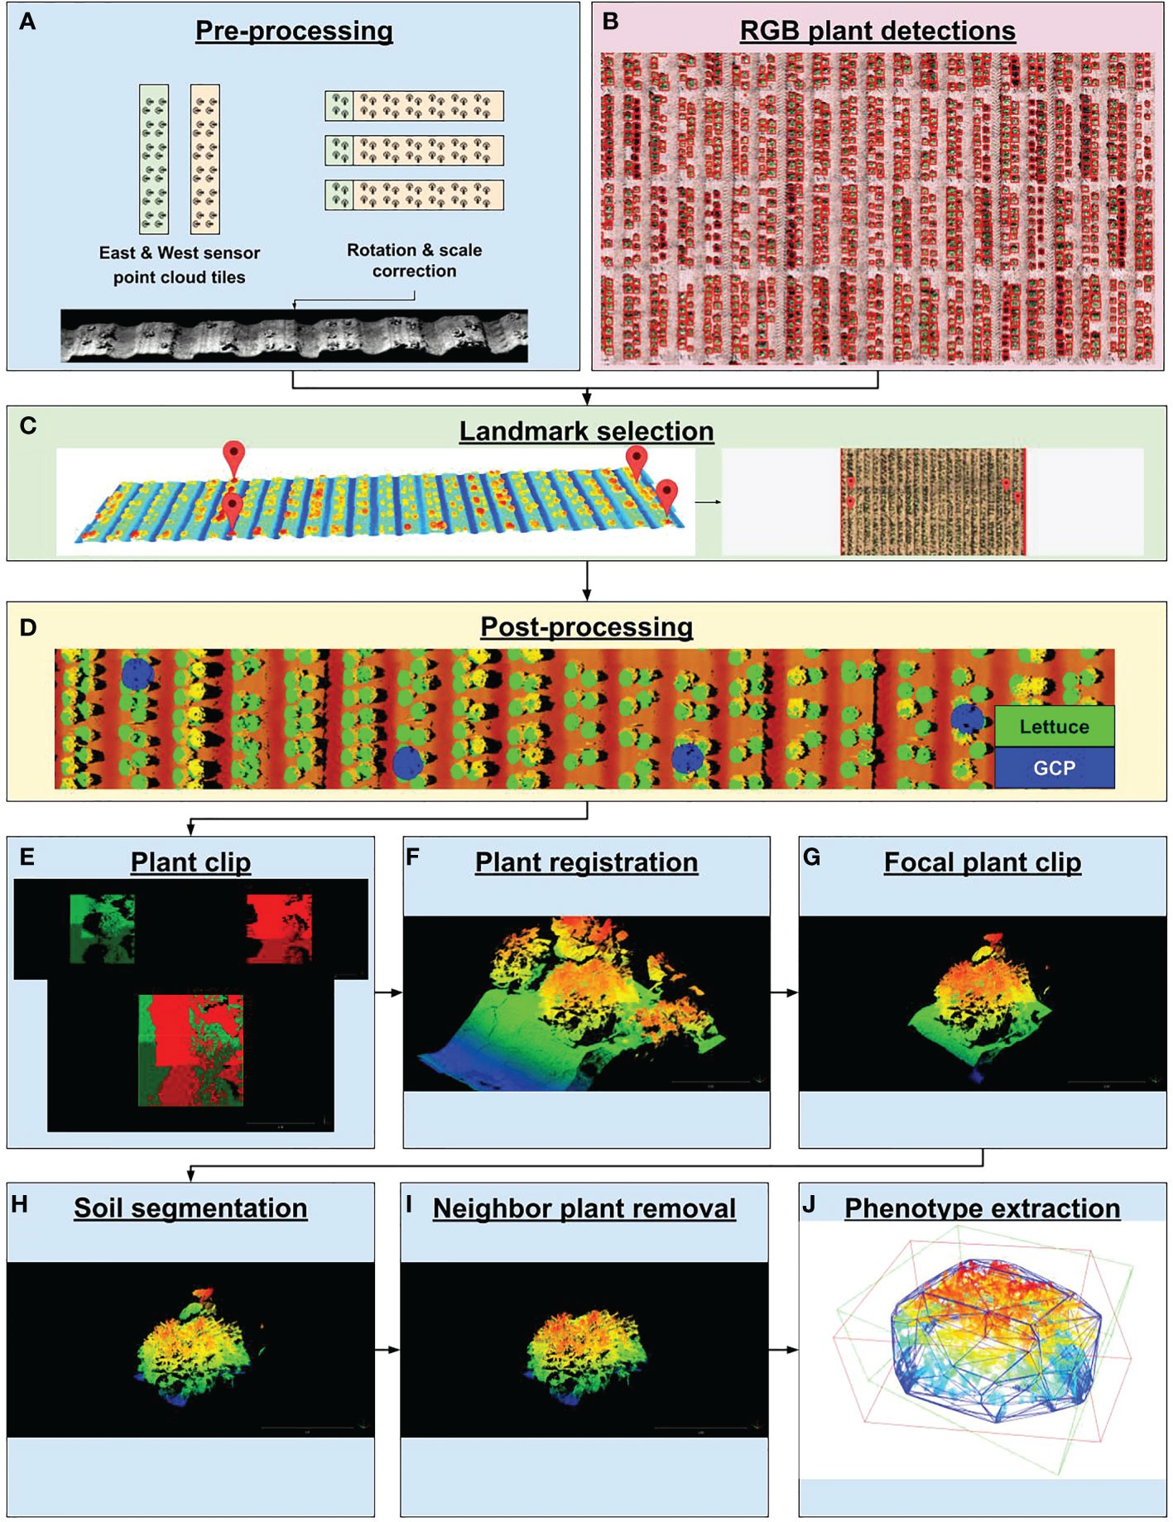

***Figure 19:*** *Visualization of 3D data processing by PhytoOracle.*

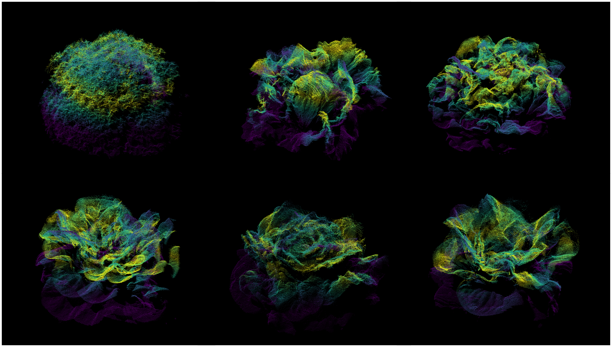

***Figure 20:*** *Individual plant point clouds processed by PhytoOracle.*

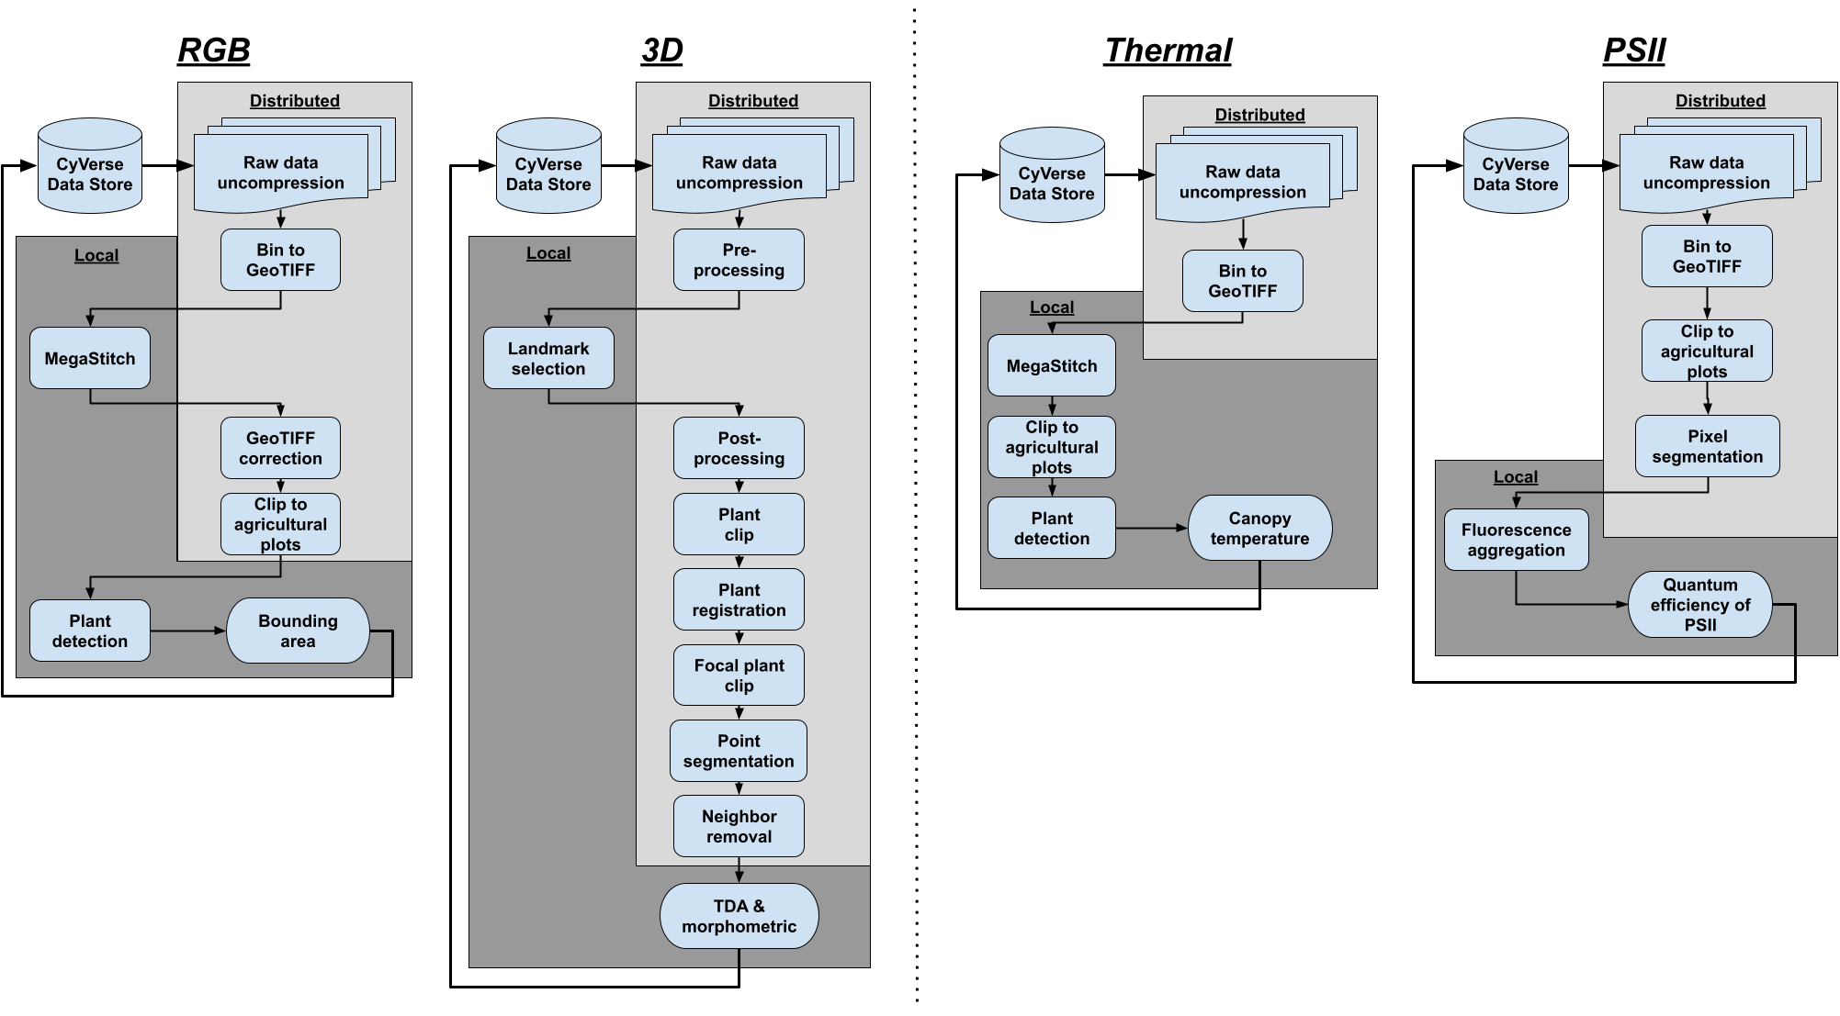

***Figure 21:*** *PhytoOracle workflows for processing raw data collected by the Field Scanner.*

PhytoOracle is mainly deployed on the UArizona HPC. The next sections provides a brief description of how to run each workflow. For additional details, please refer to the [PhytoOr-](https://doi.org/10.3389/fpls.2023.1112973) [acle publication](https://doi.org/10.3389/fpls.2023.1112973). In all cases, the commands provided will automatically handle all steps of processing, including:

* Raw data download
* Raw data extraction (.tar file)
* Launching workers
* Output archiving (.tar file)
* Output upload onto [CyVerse DataStore](https://de.cyverse.org/)

Prior to running any pipelines, users must complete the following:

* [Set up a terminal client](https://emmanuelgonz.github.io/posts/2021/09/terminal-git-irods/)
* [Register for an HPC account](https://uarizona.atlassian.net/wiki/spaces/UAHPC/pages/75990889/Account%2BCreation)
* [Create a CyVerse account](https://cyverse.org/new%20users)
* [Configure SSH keys](https://github.com/phytooracle/automation/blob/main/docs/dtn.md)

Prior to running any pipelines, the project lead must complete the following:

* [Request access for the user to PI /xdisk/](https://servicenow.arizona.edu/sp)
* [Grant permissions to directories on CyVerse](https://de.cyverse.org/)

### stereoTop

The stereoTop workflow runs image stitching and plant detection, resulting in the extraction of bounding area and GPS coordinate information for each plant. The workflow is run as follows:

sbatch shell_scripts/slurm_submission_large.sh <yaml_file>

For example, if you wanted to run this for season 15:

sbatch shell_scripts/slurm_submission_large.sh yaml_files/season_15/stereoTop_level01_s15.yaml

### flirIrCamera

The flirIrCamera workflow runs image stitching and plant detection, resulting in the extrac- tion of canopy temperature and GPS coordinate information for each plant. The workflow is run as follows:

sbatch shell_scripts/slurm_submission_large.sh **<**yaml_file**>**

For example, if you wanted to run this for season 15:

sbatch shell_scripts/slurm_submission_large.sh yaml_files/season_15/flirIrCamera_level01_s15.yaml

### ps2Top

The ps2Top workflow applies a threshold to fluorescence plot-centered images, resulting in the extraction of maximum potential quantum eﬀiciency of Photosystem II (Fv/Fm).

sbatch shell_scripts/slurm_submission_large.sh **<**yaml_file**>**

For example, if you wanted to run this for season 15:

sbatch shell_scripts/slurm_submission_large.sh yaml_files/season_15/ps2Top_level01_s15.yaml

### scanner3DTop

The scanner3DTop workflow runs point cloud stitching leverages GPS coordinates collected during stereoTop processing, resulting in the extraction of traditional and topological shape descriptors for each plant. This worlflow involves multiple levels of processing, including:

* Generation of test datasets using the [test_dataset_automator repository](https://github.com/phytooracle/test_dataset_automator)
* Transformation selection using the [3d_transformation_selection repository](https://github.com/phytooracle/3d_transformation_selection)
* Level 01 processing on the UArizona HPC
* Landmark selection using the [3d_landmark_selection repository](https://github.com/phytooracle/3d_landmark_selection)
* Level 02 processing on the UArizona HPC

For example, if you wanted to run level 1 processing for season 15:

sbatch shell_scripts/slurm_submission.sh yaml_files/season_15/scanner3DTop_level01_s15.yaml

To run level 2 processing for season 15:

sbatch shell_scripts/slurm_submission.sh yaml_files/season_15/scanner3DTop_level02_s15.yaml

*Note: Notice that scanner3DTop level 1 and 2 processing uses the shell_scripts/slurm_submission.sh instead of shell_scripts/slurm_submission_large.sh.

This is because the manager node performs no processing, it merely provides the tasks and sends them to worker nodes. As such, the manager node only requires two cores instead of 94.

## Quality Control & Quality Assurance of Processed Data

Although PhytoOracle is reproducible due to the use of containers and YAML configuration files, it is important to follow quality control (QC) and quality assurance (QA) steps after data processing. The recommended steps for this are:

* Check Slack notifications (currently Cyverse/gantry_data_updates) to check for re- ported errors
* Check the [CyVerse DataStore](https://de.cyverse.org/) to confirm upload
* Visualize stereoTop, flirIrCamera orthomosaics (ending in *.tif) on [QGIS](https://qgis.org/en/site/)
* Pull level 2 scanner3DTop (individual plant point clouds) for stretching/bending or neighboring plant material (*_segmentation_pointclouds.tar)

If any errors are spotted during these QA/QC steps, immediately notify the project lead. Depending on the impact of the error, data may need to be reprocessed to ensure data integrity.



# Data Visualization

## PhytoOracle Dashboard

PhytoOracle results in vast amounts of phenotypic information, which can be used to study plant growth patterns, responses to biotic and abiotic stress, and identification of top- performing genotypes. To enable access to these information, the PhytoOracle team has developed a [Streamlit](https://streamlit.io/) app which can be accessed [here](https://phytooracle-dashboard.streamlit.app/).

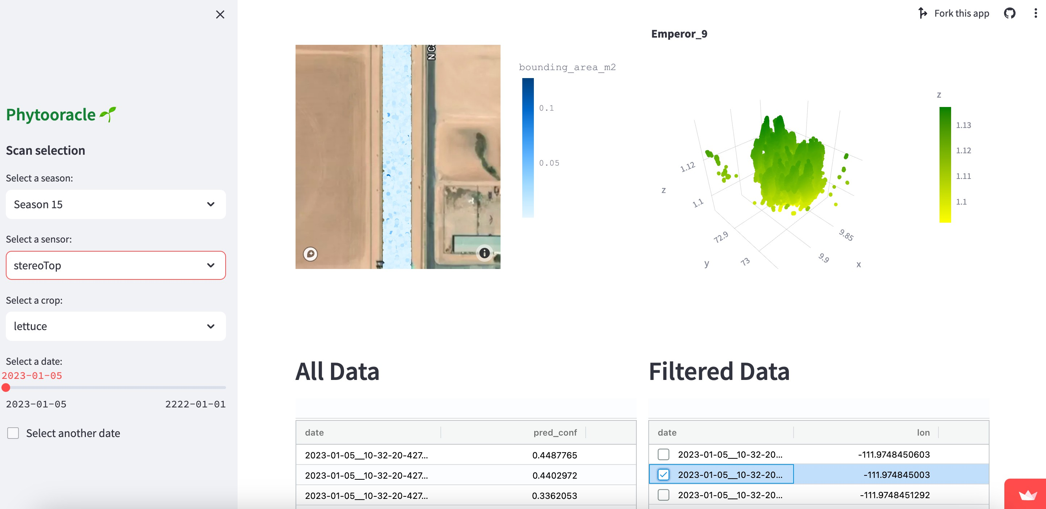

***Figure 22:*** *PhytoOracle dashboard app on Streamlit.*

The dashboard is under development at the [streamlit_dashboard](https://github.com/phytooracle/streamlit_dashboard) GitHub repository, and changes are expected. Currently, the dashboard allows users to access, filter, and download phenotype information (**Figure** **22**). This dashboard is useful to: (*i*) check quality and integrity of pipeline outputs, (*ii*) access data for research purposes, (*iii*) share progress and phenotypic information with stakeholders.